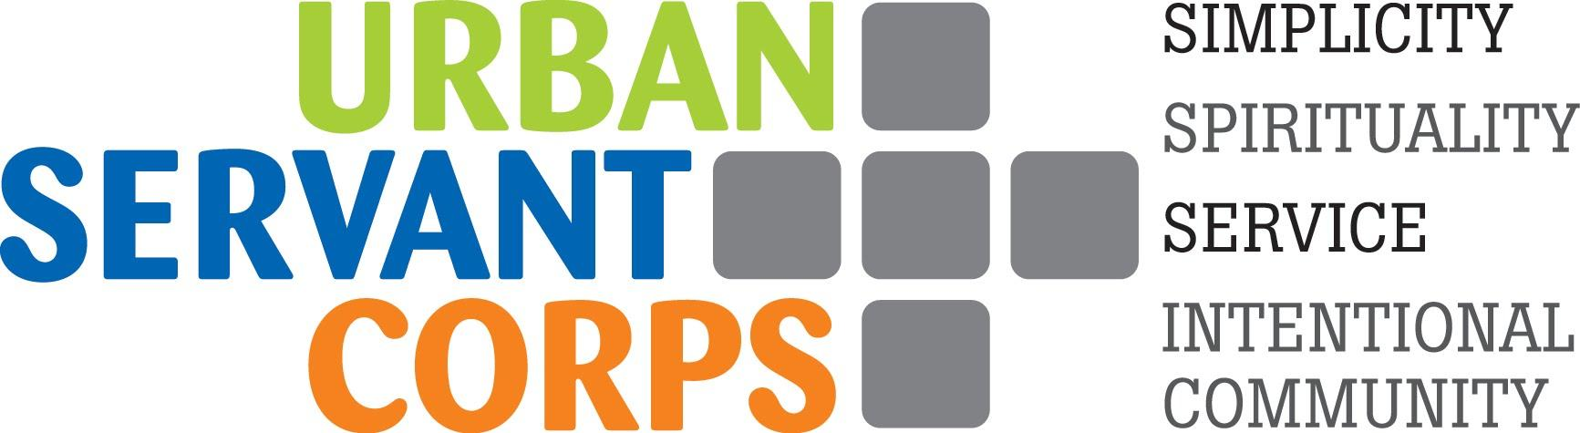
APPLICATION FOR SERVICE
Thank you for your interest in Urban Servant Corps! Please submit this application, your resume and 3 professional references to: krista@servantcorps.org

PERSONAL INFORMATION

Name/Pronouns: Date:
Phone: Email:
Date of Birth: Place of Birth:
Current Address:
Summer Address (if different from above):
Permanent Address (if different from above):
Emergency Contact: Relationship:
Address: Phone:
Marital Status: Do you have dependents?

LANGUAGE ABILITY

What is your primary language? _______________

Do you know any language(s) other than your primary language? _____ Yes _____ No
Please indicate whether you speak, write, or read in any additional language(s) as well as your proficiency level:

CHURCH OR SPIRITUAL COMMUNITY INFORMATION (If Applicable)

Name of Church/Community
Pastor/Spiritual Leader
Address
Phone Number

EDUCATION AND TRAINING

Education institutions include High School/GED, College or University, Graduate Study/Seminary, Further Graduate Study, Business/Trade/Technical, Other/Continuing Education.
List in chronological order:

Name of School and Location | Dates Attended | Degree(s) Earned

List any additional training, seminars, or other unique growth experiences:

List your leisure activities, hobbies, and talents:

List your favorite reading materials from this past year:

GENERAL

*PLEASE ANSWER THE FOLLOWING QUESTIONS IN THE SPACE BELOW THE BOX*
- WHAT HAS LED YOU TO SUBMITTING AN APPLICATION TO URBAN SERVANT CORPS?

- HAVE YOU APPLIED FOR OTHER PROGRAMS? IF SO, WHAT WILL BE THE DECIDING FACTOR?

- SELECT TWO WORDS FROM THE MISSION/VISION STATEMENT. WHY ARE THOSE IMPORTANT TO YOU?
MISSION STATEMENT
Urban Servant Corps is a faith-based, intentional community of full-time volunteers who seek to live simply while serving and accompanying those most in need through non-profit partner agencies in the heart of Denver.
VISION STATEMENT
Acting for peace with justice, advocating for and with the oppressed, and sharing our abundance as we respond to Christ’s call to love.

SERVICE
USC service sites meet direct needs of people affected by poverty, hunger, immigration, domestic violence, education, health care, and more. In addition, volunteers are encouraged to examine the systems which contribute to these needs. Part of this work is external – examining what we do; part is internal – being aware of our own experience with oppression and privilege, and being open to discussion about racism, sexism, heterosexism, economic injustice, and other forms of oppression. Service is not just at the service site, but also includes service to the USC community members, service to the community, and beyond.

- IF YOU COULD PICK A DREAM JOB, WHAT WOULD YOUR TASKS INCLUDE? AT WHAT TYPE OF AGENCY SITE ARE YOU INTERESTED IN SERVING?

- SCENARIO QUESTION: You are serving at a non-profit organization that provides emergency food and other services to guests. As you speak with a guest, they become irate at the lack of services that he or she can obtain that particular day and claims you are a worthless employee. They proceed to yell about your privilege and assume that a person of your background would never understand this circumstance. There are a number of other guests who are waiting to be served and are overhearing bits and pieces of this conversation. How do you respond?

SPIRITUALITY
Urban Servant Corps is a ministry of the Evangelical Lutheran Church in America (ELCA). Typically, USC volunteers identify as having grown up with a Christian practice, though many volunteers identify across a spectrum of their spiritual journeys. This tenet is lived out, in part, through monthly Christian worship and volunteer-led faith reflections. USC expects volunteers to bring their whole selves as they are – to share, practice, question, learn, and discern individually and communally. Volunteers are encouraged to have conversations and support one another in each person’s unique spiritual journey.

- WHY ARE YOU INTERESTED IN SERVING WITH A FAITH-BASED VOLUNTEER PROGRAM?

- USC IS A RECONCILING IN CHRIST PROGRAM WHICH MEANS USC IS COMMITTED TO WELCOMING AND AFFIRMING PEOPLE WHO ARE GAY, LESBIAN, BISEXUAL, AND TRANSGENDER. WHAT IS YOUR PERSPECTIVE ON THIS?

- SHARE ABOUT YOUR FAITH/SPIRITUAL JOURNEY. HOW WOULD YOU LIKE TO BE SUPPORTED IN YOUR FAITH/SPIRITUAL JOURNEY DURING THIS YEAR OF SERVICE?

INTENTIONAL COMMUNITY LIVING
Urban Servant Corps understands intentional community as a space for volunteers to support one another, despite differences. Volunteers share material resources, spiritual practices, recreational time, and the joys and challenges of daily life. Community gives us the strength to reach out to those we work alongside and challenges us to be open, compassionate, and willing to change. USC expects volunteers to recognize their interdependence and responsibility to one another. Community life requires effective communication, conflict management, self-care, and commitment.

- WHAT UNIQUE GIFTS WILL YOU BRING TO AN INTENTIONAL COMMUNITY LIVING EXPERIENCE?

- SHARE ABOUT A TIME YOU COMMUNICATED WITH SOMEONE IN A TENSE MOMENT OR TIME OF CONFLICT THAT RESULTED IN A POSITIVE OUTCOME.

SIMPLICITY
Urban Servant Corps understands simple living as more than material goods. This practice includes intentional stewardship of our relationship with resources – economically, environmentally, relationally, and time. Simplicity’s intersection with community, service, and spirituality more deeply informs our process of reexamining and living out our values in a manner that allows us to live more justly in the world.

- WHY IS LIVING SIMPLY AND SUSTAINABLY IMPORTANT TO YOU?

- WHAT MEASURES DO YOU INTEND TO TAKE THAT WILL ACCOMPLISH YOUR PERSONAL AND COMMUNAL FULFILLMENT OF THE TENET OF SIMPLICITY? WHAT WOULD YOU LIKE TO LEARN MORE ABOUT WITHIN THE SIMPLICITY TENET?

MISCELLANEOUS

- HOW DID YOU HEAR ABOUT URBAN SERVANT CORPS?

- DO YOU HAVE A VALID DRIVER’S LICENSE? DO YOU PLAN TO BRING A CAR? COULD YOU BRING A CAR IF YOUR PLACEMENT REQUIRED ONE?

- USC staff is committed to providing strong support throughout the year of service. DO YOU HAVE ANY FINANCIAL OBLIGATIONS, SPECIAL CIRCUMSTANCES (recent death of a loved one, a sickness in your family, etc.) OR PERSONAL HEALTH CONCERNS (physical, mental, emotional, etc.) THAT MAY HAVE A SIGNIFICANT IMPACT ON YOUR TERM OF SERVICE?

Rate yourself on the following using the scale below:
5 – Excellent 4 – Above Average 3 – Average 2 – Below Average 1 – No Experience
Listening -- | Reliability --
Creativity -- | Taking initiative --
Resiliency -- | Emotional Maturity --
Care for self -- | Follow through with commitments --
Conflict Management -- | Awareness of peace and justice issues --

OTHER THOUGHTS YOU WISH TO EXPRESS?

**Please attach a resume that includes job experience and applicable educational courses as well as contact information for 3 professional references. Send to krista@servantcorps.org**
If selected to participate in Urban Servant Corps, I will commit to community life and to working hard at my placement agency. I understand that there is a significant level of responsibility with this commitment and that Urban Servant Corps staff and agency supervisors expect me to uphold the tenets of the organization and seek to fulfill its mission.
I have represented myself truthfully in this application.
Signed ____________________________________ Date _____________

If accepted, USC would like to share your application with partner service sites prior to an interview with them. Do you grant permission to share this application with prospective service placement sites?
_____ (initial)

